Accepts any string in a^nb^ma^(m+n) n >= 1

Adapted from geeks4geeks

Accepting input string: abaa

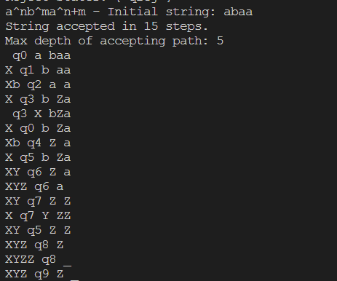

Rejecting input string:



Steps –

Step-0: Convert “a” into “X”, move right and go to state 1. If symbol is “b”, ignore it, move right and go to state-4.

Step-1: If symbol is “a”, ignore it and move right, remain on same state. If symbol is “b”, ignore it, move right and go to state-2.

Step-2: If symbol is “Z”, ignore it and move right, remain on same state. If symbol is “b”, ignore it and move right, remain on same state and if symbol is “a”, convert it into “Z”, move left and go to state-3.

Step-3: If symbol is “Z”, ignore it and move left, remain on same state. If symbol is “b”, ignore it and move left, remain on same state. If symbol is “a”, ignore it and move left, remain on same state, and if symbol is “X”, ignore it and move right, go to state-0.

Step-4: If symbol is “b”, ignore it and move left, go to state 5, and if symbol is “Z”, ignore it and move left, go to state-5.

Step-5: Convert “b” into “Y”, move right and go to state 6, and if symbol is “Z”, ignore it and move right, go to state-8.

Step-6: If symbol is “Z”, ignore it and move right, remain on same state. If symbol is “b”, ignore it and move right, remain on same state, and if symbol is “a”, convert it into “Z”, move left and go to state-7.

Step-7: If symbol is “Z”, ignore it and move left, remain on same state. If symbol is “b”, ignore it and move left, remain on same state, and if symbol is “Y”, ignore it and move right, go to state-5.

Step-8: If symbol is “Z”, ignore it and move right, remain on same state, and if symbol is “$”, ignore it and move left, go to state-9.

Step-9: String ACCEPTED

State diagram:

